Microservices Project using Spring Boot
In this tutorial, we will learn how to build a simple Microservices project using Spring Boot 3, Spring Cloud, and PostgreSQL database.
In this microservices project, you'll explore essential concepts such as API Gateway, Config Server, Discovery Server, and hands-on implementation of two real-world microservices, Student and School.
Prerequisites
Ensure you have the following software installed on your system before proceeding:
- Java Development Kit (JDK) 17 or later
- Maven
- Docker (optional, for containerization)
Microservices Architecture
Here is the Microservices Architecture for our Microservices project that we are going to build in this tutorial:
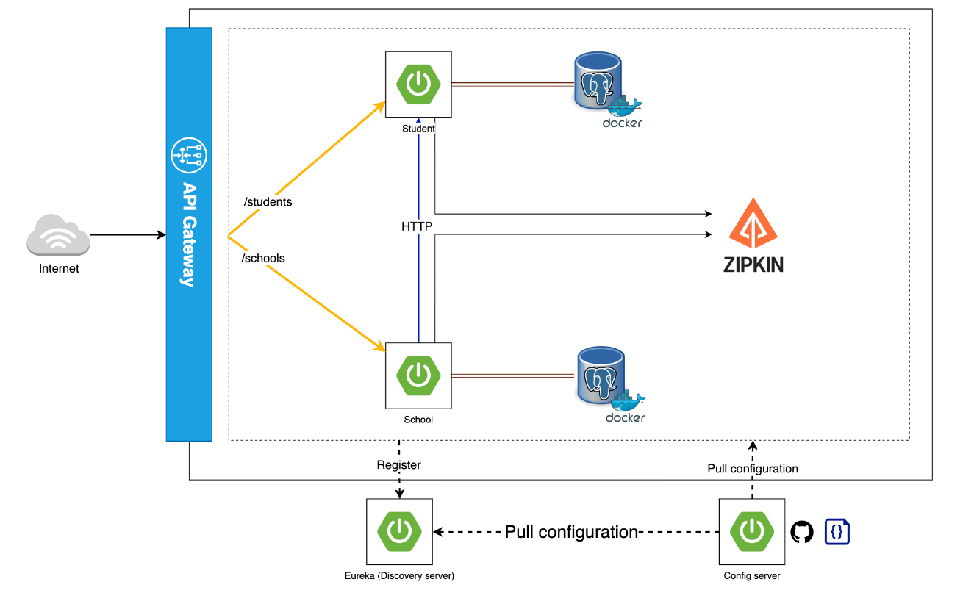
Let's understand the Microservices project components:
API Gateway
The API Gateway serves as the single entry point for all client requests, managing and routing them to the appropriate microservices.
Config Server
The Config Server centralizes configuration management for all microservices, simplifying application maintenance and consistency across environments.
Discovery Server
The Discovery Server provides service registration and discovery, enabling seamless service-to-service communication within the microservices ecosystem.
Student Microservice
The Student Microservice is responsible for managing student-related data and operations, such as adding, updating, and retrieving student records.
School Microservice
The School Microservice manages school-related data and operations, including adding, updating, and retrieving school records.
Using OpenFeign - Inter-Service Communication
This project demonstrates inter-service communication using OpenFeign, a declarative REST client that simplifies service-to-service communication within the microservices ecosystem.
Distributed Tracing - Using Zipkin
The project showcases the use of Zipkin for distributed tracing, enhancing application observability and enabling the visualization and troubleshooting of latency issues.

Create Student Microservice
Let's build student microservice step by step.
Create Spring Boot Project
Let's create a student microservice as a Spring boot project using the spring initializr.
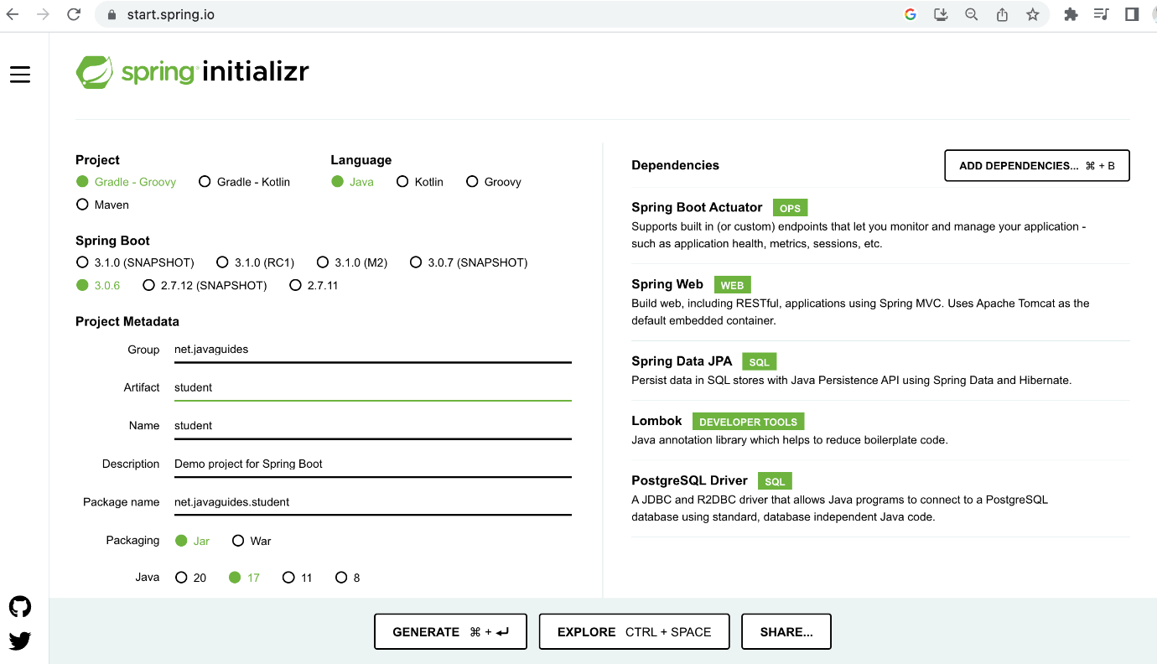
Here is the complete pom.xml file for your reference:
<?xml version="1.0" encoding="UTF-8"?>
<project xmlns="http://maven.apache.org/POM/4.0.0" xmlns:xsi="http://www.w3.org/2001/XMLSchema-instance"
xsi:schemaLocation="http://maven.apache.org/POM/4.0.0 https://maven.apache.org/xsd/maven-4.0.0.xsd">
<modelVersion>4.0.0</modelVersion>
<parent>
<groupId>org.springframework.boot</groupId>
<artifactId>spring-boot-starter-parent</artifactId>
<version>3.0.6</version>
<relativePath/> <!-- lookup parent from repository -->
</parent>
<groupId>net.javaguides</groupId>
<artifactId>student</artifactId>
<version>0.0.1-SNAPSHOT</version>
<name>student</name>
<description>Demo project for Spring Boot</description>
<properties>
<java.version>17</java.version>
</properties>
<dependencies>
<dependency>
<groupId>org.springframework.boot</groupId>
<artifactId>spring-boot-starter-actuator</artifactId>
</dependency>
<dependency>
<groupId>org.springframework.boot</groupId>
<artifactId>spring-boot-starter-data-jpa</artifactId>
</dependency>
<dependency>
<groupId>org.springframework.boot</groupId>
<artifactId>spring-boot-starter-web</artifactId>
</dependency>

<dependency>
<groupId>org.postgresql</groupId>
<artifactId>postgresql</artifactId>
<scope>runtime</scope>
</dependency>
<dependency>
<groupId>org.projectlombok</groupId>
<artifactId>lombok</artifactId>
<optional>true</optional>
</dependency>
<dependency>
<groupId>org.springframework.boot</groupId>
<artifactId>spring-boot-starter-test</artifactId>
<scope>test</scope>
</dependency>
</dependencies>

<build>
<plugins>
<plugin>
<groupId>org.springframework.boot</groupId>
<artifactId>spring-boot-maven-plugin</artifactId>
<configuration>
<excludes>
<exclude>
<groupId>org.projectlombok</groupId>
<artifactId>lombok</artifactId>
</exclude>
</excludes>
</configuration>
</plugin>
</plugins>
</build>

</project>

Configure PostgreSQL Database
Create an application.yml file under /resources folder and add the following content:
server:
port: 8090
spring:
application:
name: students
datasource:
driver-class-name: org.postgresql.Driver
url: jdbc:postgresql://localhost:5432/students
username: username
password: password
jpa:
hibernate:
ddl-auto: create
database: postgresql
database-platform: org.hibernate.dialect.PostgreSQLDialect
Don’t forget to change the spring.datasource.username and spring.datasource.password as per your PostgreSQL installation. Also, create a database named students in PostgreSQL before proceeding to the next section.

You don’t need to create any tables. The tables will automatically be created by Hibernate from the Student entity that we will define in the next step. This is made possible by the property spring.jpa.hibernate.ddl-auto = create.
JPA Entity – Student
Let's create a Student JPA entity and add the following code to it:
import jakarta.persistence.Entity;
import jakarta.persistence.GeneratedValue;
import jakarta.persistence.Id;
import lombok.*;

@Entity
@Getter
@Setter
@AllArgsConstructor
@NoArgsConstructor
@Builder
public class Student {

@Id
@GeneratedValue
private Integer id;
private String firstname;
private String lastname;
private String email;
private Integer schoolId;
}

